**Project Report**

ON

Shopping cart

**Towards partial fulfillment of the requirement**

**For the award of degree of**

**TABLE OF CONTENTS**

Title of the project………………………………………………………….1

Introduction & Objective of the Project………..................2-3

Tools /Environment Used………………………………………..4

Requirement and Analysis………………………………………………..5-12

* 1. Feasibility Study……………………………………………………..7-8
  2. Problem Definition………………………………………………..8
  3. Project scheduling…………………………………………………..9
  4. Data Flow Diagram…………………………………………………10-11

Complete Structure………………………..................................11-17

1. Modules and their description……………………………………11
2. Data structure…………………………………………………………….12-15
3. Process logic of the modules………………………………………16
4. List of reports generated ……………………………………………17

Project Code………………………………………………………………18-141

Testing…………………………………………………………………18-141

Project Screenshot…………………………………………………144-148

Implementation of Security…………………………………..142-143

Future scope and enhancement…………………………………155

Conclusion ………………………………………………..................156

1. **TITLE OF THE PROJECT**

**SHOPPING CART**

2. INTRODUCTION OF THE PROJECT

Shopping cart is a very important feature used in e-commerce to assist people making purchases online, similar to the US English term ‘shopping cart’.

Shopping Cart feature allows online shopping customers to “place” items in the cart. Upon “checkout” the software calculates as total for the order including shipping and handling postage, packing and taxes, if applicable. The Shopping Cart is very important feature used in e-commerce to assist people making purchases products online. It provides the user a catalog of different products available in the system. In order to purchase a shopping cart is provided to the user. The shopping cart application has been developed to allow business grows larger and faster. This site will let customers to view and order products online from any part of the world. Under this website many products and services can be ordered. The shopping cart is expanded permanently through new products and services in order to offer a product portfolio corresponding to the market.

2.1. OBJECTIVES OF THE PROJECT

The project entitled “Shopping Cart” enables customer to buy mobiles or accessories from anywhere through online. This application advertises some of the products for shopping. To buy products, customer has to create an account. Those who does not have an account, they can only view the available product. They can’t buy it. Once the customer has created account, not only he can view the products, he can also add the product to the cart and also he can place an order to buy those products. After the confirmation, the customer can buy those products. The mode of billing is cash on delivery.

So the objective of this project is to overcome the limitation of the manual approach. This project is started towards systematically automating all the work that is done manually at present. Their aim is to focus following aspects:

* The main objective is to automate non computer environment
* To save manpower.
* It will speed the processing of data and transaction.
* It will provide all the error reporting and handling features, so that the user is warned and made aware of any foreseen errors. Thus it will reduce the error rate.
* It will provide various ways through which we generate various types of report.

It will provide best security features such as provisions of passwords.

3. TOOLS/ENVIRONMENT USED

**3.1 Hardware Requirement for Server Side :**

|  |  |
| --- | --- |
| **COMPONENT** | **MINIMUM SPECIFICATION** |
|  |  |
| 1. Processor | Pentium IV |
| 1. Memory | 512 MB |
| 1. HDD | 1. B |

**3.2 Software Requirement :**

|  |  |
| --- | --- |
| **Use of Software** | **Name of Software** |
|  |  |
| 1. Operating System | Window 7, XP-SP3 |
| 1. Front End | HTML,Bootstrap 4, Jquery,  CSS,JavaScript |
| 1. Back End | MySql ,Python,Django |
| 1. For Documentation | MS-Office 2007 |

**4-REQUIREMENTS AND ANALYSIS**

**4.1FEASIBILITY STUDY :**  
All projects are feasible given unlimited resources and infinite time. Unfortunately the development of computer-based system in many cases is more likely to be plagued by scarcity of resources and delivery date. Hence, we have made use the concept of reusability that is what Object Oriented Programming (OOPS) is all about.  
The feasibility report of the project holds the advantages and flexibility of the project. This is divided into three sections:

1. Economical Feasibility
2. Technical Feasibility
3. Behavioral Feasibility  
    **1. Economic Feasibility :**  
   Economic analysis is the most frequently used method for evaluating the effectiveness of the candidate system. More commonly known as cost/benefit analysis, the procedure is to be determining the benefits and savings that are expected from a candidate and compare them with costs. If benefits outweigh costs, then the decision is made to design and implement the system.

A systems financial benefit must exceed the cost of developing that system. i.e. a new system being developed should be a good investment for the organization. Economic feasibility considers the following:  
**i.** The cost to conduct a full system investigation.   
**ii.** The cost of hardware and software for the class of application.   
**iii**. The benefits in the form of reduced cost or fewer costly errors.   
**iv**. The cost if nothing changes (i.e. the proposed system is not developed).

The proposed **Shopping Cart** is economically feasible because  
**i.** The system requires very less time factors. 

**ii**. The system will provide fast and efficient automated environment instead of slow and error

prone manual system, thus reducing both time and man power spent in running the system.  
**iii**. The system will have GUI interface and very less user-training is required to learn it.

**iv**. The system will provide service to view various information for proper managerial decision making. 

**2. Technical Feasibility:**  
Technical feasibility centers around the existing computer system (Hardware and Software etc) and to what extend it support the proposed addition.

In this project, all the necessary cautions have been taken care to make it technically feasible. Using a key the display of text/object is very fast. Also, the tools, operating system and programming language used in this localization process is compatible with the existing one.  
 **3. Behavioral Feasibility:**  
People are inherently resistant to change, and computers have been known to facilitate change. An estimate should be made of how strong a reaction the user staff is likely to have toward the development of a computerized system. Therefore it is understandable that the introduction of a candidate system requires special efforts to educate and train the staff. The software that is being developed is user friendly and easy to learn. In this way, the developed software is truly efficient and can work on any circumstances , tradition ,locales. Behavioral study strives on ensuring that the equilibrium of the organization and status quo in the organization are nor disturbed and changes are readily accepted by the users.

**4.2PROBLEM DEFINITION**

**DISADVANTAGES OF OLD SYSTEM**  
  
As we know the manual processing is quite tedious, time consuming, less accurate in comparison to computerized processing. Obviously the present system is not is exception consultant encountering all the above problems.  
**1.** Time consuming.  
**2.** It is very tedious.  
**3.** All information is not placed separately.  
**4.** Lot of paper work.  
**5.** Slow data processing.  
**6.** Not user-friendly environment.  
**7.** It is difficult to found records due file

**ADVANTAGES OF NEW SYSTEM**  
  
In new computerized system I tried to give these facilities.  
**1.** Manually system changes into computerized system.  
**2.** Friendly user interface.  
**3.** Time saving.  
**4.** Save paper work.  
**5.** Connecting to database so we use different type of queries, data report.  
**6.** Give facility of different type of inquiry.  
**7.** Formatted data.

* 1. **PROJECT SCHEDULING**

**GANTT CHART**

|  |  |  |  |  |  |  |  |  |
| --- | --- | --- | --- | --- | --- | --- | --- | --- |
| **Task No**. | **Task** | **oct- Nov** | **Nov-Dec** | **dec - Jan** | **Jan- Feb** | **Feb-Mar** | **Mar- Apr** | **Apr- may** |
| 1 | Requirement Analysis |  |  |  |  |  |  |  |
| 2 | Design |  |  |  |  |  |  |  |
| 3 | Coding |  |  |  |  |  |  |  |
| 4 | Testing |  |  |  |  |  |  |  |
| 5 | Documentation |  |  |  |  |  |  |  |
| 6 | Implementation |  |  |  |  |  |  |  |
| 7 | Final Review |  |  |  |  |  |  |  |

* 1. **Data Flow Diagram**

0 LEVEL DFD : CONTEXT DIAGRAM

**Order List Report**

**Order details**

**Authentication Information**

**Authentication**

**Report**

**Products Information**

**Product Reports**

**User Information**

**User Report**

**Billing request**

**Billing report**

**Admin**

**Report**

**Admin Information**

### SHOPPING

### CART

[8]

1 LEVEL DFD

Customer Information

Order Information

Bill Generate

Customer

Update

**Database**

Administrator

Product Information Information

2 LEVEL DFD

Cart Item

Confirmation

**Customer**

**Admin**

Edit/Update Catalogue

Browse

Shopping Cart

Quantity

Item Details

Order/Billing Information

**Admin**

Item Details

**Shipping Agent**

**4.5 ER Diagram**

User/Customer

Admin

Buy

Manages

Generate

Report

Product

**5. COMPLETE STRUCTURE**

**5.1 MODULES & THEIR DESCRIPTION**

**The modules involved are:**

1. Administrator
2. Users
3. Reports

**Administrator:-**

The administrator is the super user of this application. Admin only access to enter into this admin page. Admin had all privileges to give authenticate to user and gives privileges that which portion they can access. The administrator has all the information about all the users and about all products.

This module is divided into different sub-modules.

1. Manage Category
2. Manage Products
3. Manage Users
4. Manage Orders History
5. Reports
6. **Manage Category:**

a. Add Category:

The shopping cart project contains different kind of products. The products can be classified into different categories. Admin can add new category into the existing system.

b. Edit Category:

Based on the market analysis admin can update a category. He can change the category of a particular product.

c. Delete Category:

Admin has privilege to delete a category from the existing system.

d. View Category:

All existing categories can view by the administrator. The administrator can keep track on categories.

1. **Manage Products:**
2. Add Products:

The shopping cart project contains different kind of products. The products can be classified into different categories. Admin can add new products into the existing system and he can map with the category.

b. Edit Products:

Based on the market position admin will modify the product details like price, quantity, packing etc.

c. Delete Products:

Administrator can delete the products based on the category.

* 1. View Products:

Administrator can view the product details. He can watch the products prices and contents of the products.

1. **Manage Users:**

a. View Users:

Admin can view the user details which are registered in his system because he must know how many users entered his site and purchase products. So he can keep track on user’s information.

b. Edit Users:

Admin has privileges to edit particular user information, which is requested by the users.

1. Delete Users:

Administrator has a right to delete user information without intimation.

1. **Manage Order History:**
   1. View the Order History:

Administrator can view the Order History which is generated by the user. He can verify the products and their prices.

* 1. Generate Bill For History:

Administrator generates the bill for order list which is prepared by the users.

* 1. Set Status:

Admin can set the status for the Order list which is given by the user. The status can be different types as follows.

* + - * + Shifted
        + Delivered
        + Cancelled
        + Rejected

**USERS:-**

**1. View Products:**

User can view the list of products based on their categories. A detailed description of a particular product can be displayed to the user, products details, manufactured by, price and date of manufacture etc…

**2. Select Order Products:**

After verifying the products details users select some required products.

**3. Generate Order Products:**

When ever user completes his selection of product, he can add these selected products into shopping cart, for this he must be an authenticated person. If he is not an authenticated person his selected products should not add into shopping cart. Then he needs to register himself. If he is registered person he can directly generates the Order Products.

**4. Registration:**

A registered user only can purchase products from online. So that if a user want to purchase products he must be fill his registration form an must obtain a valid user name and password which is provided by the administrator.

**5. View Shopping Cart:**

If a user generates an Order List after that he may watch which products selected by himself. The user can also view previous shopping cart which is generated by him.

1. **Billing:**

After submit his shopping cart user must pay his bill which is generated by the administrator. The mode of billing is Cash on delivery.

**Reports:-**

Reports can be generated by the admin for various purposes. Based on the reports admin take decisions of the system. Different kinds of reports can be generated according to the requirement.

**5.2 Data Structure**

**5.2.1-Customer Registration Table**

|  |  |  |
| --- | --- | --- |
| **Field Name** | **Data Type** | **Length** |
| Uname | VARCHAR | 15 |
| Password | VARCHAR | 12 |
| Name | VARCHAR | 20 |
| Email-id | VARCHAR | 20 |
| Gender | VARCHAR | 6 |
| Contact | NUMERIC | (10,0) |
| Address | VARCHAR | 100 |
| State | VARCHAR | 20 |
| Country | VARCHAR | 20 |
| PinCode | NUMERIC | (6,0) |
| Image | VARCHAR | 50 |

**5.2.2-Admin Table**

|  |  |  |
| --- | --- | --- |
| **Field name** | **Data type** | **Length** |
| adminId | VARCHAR | 20 |
| Password | VARCHAR | 12 |

**5.2.3 Purchase Table**

|  |  |  |
| --- | --- | --- |
| **Field Name** | **Data Type** | **Length** |
| itemId | VARCHAR | 15 |
| itemName | VARCHAR | 20 |
| itemPrice | NUMERIC | (10,0) |
| itemImage | VARCHAR | 50 |
| Date | VARCHAR | 20 |
| itemCategory | VARCHAR | 20 |
| Quantity | VARCHAR | 50 |

**5.2.4 Item/Product Table**

|  |  |  |
| --- | --- | --- |
| **Column Name** | **Data Type** | **Key constraint** |
| itemId | VARCHAR | 10 |
| itemName | VARCHAR | 50 |
| itemCategory | VARCHAR | 20 |
| itemPrice | NUMERIC | (10,0) |
| itemImage | VARCHAR | 50 |
| Description | VARCHAR | 50 |

* + 1. **Cart Table**

|  |  |  |
| --- | --- | --- |
| **Column Name** | **Data Type** | **Key constraint** |
| Id | VARCHAR | 10 |
| Uname | VARCHAR | 15 |
| Name | VARCHAR | 50 |
| Category | VARCHAR | 20 |
| Price | NUMERIC | (10,0) |
| Image | VARCHAR | 50 |
| Quantity | VARCHAR | 10 |

* + 1. **News Table**

|  |  |  |
| --- | --- | --- |
| **Column Name** | **Data Type** | **Key constraint** |
| NewsId | VARCHAR | 10 |
| News | VARCHAR | 50 |

**5.2.6 Feedback Table**

|  |  |  |
| --- | --- | --- |
| **Column Name** | **Data Type** | **Key constraint** |
| Name | VARCHAR | 20 |
| Address | VARCHAR | 20 |
| Mobile | NUMERIC | (10,0) |
| Email | VARCHAR | 20 |
| Query | VARCHAR | 100 |

**5.3** PROCESS LOGIC OF THE MODULES

To ensure that solve difficult problems by making the system should have the following functions:

* + - 1. Admin Functionalities.
      2. Customer Functionalities.

1. **Admin Functionalities :**

* Login to the System and change his password after login.
* Add new item categories to the Product catalogue.
* Add product list to the system.
* Edit/Update item details to the system.
* Generate various reports about product/category of the system.
* Delete item/categories from the product list.
* Manage Users and Order history.

1. **Input :**

- Product Category detail, Product details, Purchase item detail.

1. **Process :**

- Authentication of existing Username and password.

- Save to database when add /update/delete item/categories.

- Manage Order history (Shifted/ Delivered/ Cancelled/ Rejected).

**c.** **Output:**

- Product information, Payment information, Invoice information, Users information, Delivery information

1. **Customer Functionalities :**

* Login to the System through the initial screen of the system and change his password after login.
* View item by Cart system.
* Buy items and pay bill for the same. The mode of billing is Cash on delivery.

1. **Input :**

- Cart details, Purchase Item details

1. **Process :**

- Search database based on the cart system

- Purchase item and add it to cart.

- After shopping finally checkout.

- Pay bill when stuff received.

1. **Output :**

- Invoice information, Delivery information, and Payment information.

* 1. **LIST OF REPORTS GENERATED**

- Customer info report

- Cart details report

- Products details report

- Products Delivery Status report

- Sales report

- Customer Feedback report

**6. Project Code**

**homepage :**

{% extends 'base.html' %}

{% load static %}

{% block content %}

<div class="menu">

<ul>

<li class="active"><a href="/">Home</a></li>

<li><a href="{% url 'newproducts' %}">New Products</a></li>

<li><a href="{% url 'specialoffer' %}">Special Offers</a></li>

<li><a href="{% url 'myaccount' %}">My Account</a></li>

<li><a href="{% url 'cartitems' %}">Shopping Cart</a></li>

<li><a href="{% url 'location' %}">Locations</a></li>

<li><a href="{% url 'news' %}">News</a></li>

<li><a href="{% url 'contact' %}">Contact Us</a></li>

<div class="clear"></div>

</ul>

</div>

<div class="clear"></div>

</div>

<div class="header_slide">

<div class="header_bottom_left">

<div class="categories">

<ul>

<h3>Categories</h3>

<li><a href="{% url 'babygift' %}">Baby Gift</a></li>

<li><a href="{% url 'birthdaygift' %}">Birthday Gift</a></li>

<li><a href="{% url 'cristamgift' %}">Cristam Gift</a></li>

<li><a href="{% url 'accentsgift' %}">Accent's Gift</a></li>

<li><a href="{% url 'toysgift' %}">Toys Gift</a></li>

<li><a href="{% url 'artificialgift' %}">Artificial Gift</a></li>

<li><a href="{% url 'valentinegift' %}">Valentine Gift</a></li>

<li><a href="{% url 'giftforher' %}">Gift For Her</a></li>

<li><a href="{% url 'giftforhim' %}">Gift For Him</a></li>

</ul>

</div>

</div>

<div class="header_bottom_right">

<div class="slider">

<div id="slider">

<div id="mover">

<div id="slide-1" class="slide">

<div class="slider-img">

<a href="preview.html"><img src="{% static 'images/gift2.png' %}" alt="learn more" /></a>

</div>

<div class="slider-text">

<h1>GIFTS<br><span>SALE</span></h1>

<h2>UPTo 20% OFF</h2>

<div class="features_list">

<h4>Get to Know More About Our Memorable Services Lorem Ipsum is simply dummy text</h4>

</div>

<a href="preview.html" class="button">Shop Now</a>

</div>

<div class="clear"></div>

</div>

<div class="slide">

<div class="slider-text">

<h1>GIFTS<br><span>SALE</span></h1>

<h2>UPTo 40% OFF</h2>

<div class="features_list">

<h4>Get to Know More About Our Memorable Services</h4>

</div>

<a href="preview.html" class="button">Shop Now</a>

</div>

<div class="slider-img">

<a href="preview.html"><img src="{% static 'images/slide-3-image.jpg' %}" alt="learn more" /></a>

</div>

<div class="clear"></div>

</div>

<div class="slide">

<div class="slider-img">

<a href="preview.html"><img src="{% static 'images/gift4.png' %}" alt="learn more" /></a>

</div>

<div class="slider-text">

<h1>GIFTS<br><span>SALE</span></h1>

<h2>UPTo 10% OFF</h2>

<div class="features_list">

<h4>Get to Know More About Our Memorable Services Lorem Ipsum is simply dummy text</h4>

</div>

<a href="preview.html" class="button">Shop Now</a>

</div>

<div class="clear"></div>

</div>

</div>

</div>

<div class="clear"></div>

</div>

</div>

<div class="clear"></div>

</div>

</div>

<div class="main">

<div class="content">

<div class="content_top">

<div class="heading">

<h3>New Products</h3>

</div>

<div class="see">

<p><a href="#">See all Products</a></p>

</div>

<div class="clear"></div>

</div>

<div class="section group">

{% for i in product %}

{% if forloop.counter < 5 %}

{% csrf_token %}

<a href="{% url 'viewproduct' i.id %}">

<div class="grid_1_of_4 images_1_of_4" style="margin: 1% 0 1% 1%;height: 350px;">

<img src="/media/{{i.Image}}" alt="" />

<h2>{{i.desc|slice:"0:25"}}...</h2>

<div class="price-details">

<div class="price-number">

<p><span class="rupees">${{i.price}}</span></p>

</div>

</a>

<div class="add-cart">

<h4><a href="{% url 'cart' i.id %}">Add to Cart</a></h4>

</div>

<div class="clear"></div>

</div>

</div>

{% endif %}

{% endfor %}

</div>

</div>

</div>

</div>

{% endblock %}

**Login :**

{% load static %}

<!DOCTYPE html>

<html>

<head>

<title>Login Page</title>

<link href="https://unpkg.com/aos@2.3.1/dist/aos.css" rel="stylesheet">

<script src="https://unpkg.com/aos@2.3.1/dist/aos.js"></script>

<meta charset="utf-8">

<meta name="viewport" content="width=device-width, initial-scale=1">

<link rel="stylesheet" href="https://maxcdn.bootstrapcdn.com/bootstrap/3.4.0/css/bootstrap.min.css">

<script src="https://ajax.googleapis.com/ajax/libs/jquery/3.4.1/jquery.min.js"></script>

<script src="https://maxcdn.bootstrapcdn.com/bootstrap/3.4.0/js/bootstrap.min.js"></script>

<link rel="stylesheet" href="https://cdnjs.cloudflare.com/ajax/libs/font-awesome/4.7.0/css/font-awesome.min.css">

<style type="text/css">

body{

margin: 0;

padding: 0;

font-family:century gothic;

color:white;

}

#main{

background-image:linear-gradient(#B81D22,grey,black);

background-size:100% 100%;

}

#jumb{

position:relative;

background-color: rgba(0,0,0,0);

color:white;

}

a{

color:white;

}

#abc{

background-color: rgba(0,0,0,0.1);

padding: 40px;

margin-bottom:100px;

}

</style>

</head>

<body>

<div class="container-fluid" id='main'>

<div class="container jumbotron" id='jumb'>

<div class="col-md-4 col-lg-4 col-sm-1">

</div>

<div class="col-md-4 col-lg-4 col-sm-10" id='abc'>

<center>

<img src="{% static 'images/logo2.png' %}" alt="" />

</center>

<h2 style="text-align: center;">Account Login</h2>

<form action="{% url 'login' %}" method="POST">

{% csrf_token %}

{% for message in messages %}

<div class="alert alert-{{ message.tags }} alert-dismissible" role="alert">

<button type="button" class="close" data-dismiss="alert" aria-label="Close">

<span aria-hidden="true">&times;</span>

</button>

{{ message }}

</div>

{% endfor %}

{% csrf_token %}

<div class="form-group" style="padding: 5px 0px;">

<label for='username'>Username:</label>

<input type="text" class='form-control' name="username">

</div>

<div class="form-group" style="padding: 5px 0px;">

<label for='password'>Password:</label>

<input type="password" class='form-control' name="password">

</div>

<div class="form-group" style="padding: 10px 0px;">

<input type="submit" class="btn btn-success form-control" name="login" value="Login" style="padding: 5px 30px;">

</div>

<p style="font-size:16px; font-style:bold;color:white;text-align: center; margin-bottom: 20px;">Forget Password? <a href="#"> Click Here</a></p>

<p style="font-size:16px; font-style:bold;color:white;text-align: center;">Do not an account? <a href="{% url 'register' %}"> Click Here</a></p>

</form>

</div>

<div class="col-md-4 col-lg-4 col-sm-1"></div>

</div>

</div>

</body>

</html>

**User Account :**

{% load static %}

<!DOCTYPE html>

<html lang="en">

<head>

<title>Bootstrap Example</title>

<meta charset="utf-8">

<meta name="viewport" content="width=device-width, initial-scale=1">

<link rel="stylesheet" href="https://maxcdn.bootstrapcdn.com/bootstrap/3.4.0/css/bootstrap.min.css">

<script src="https://ajax.googleapis.com/ajax/libs/jquery/3.4.1/jquery.min.js"></script>

<script src="https://maxcdn.bootstrapcdn.com/bootstrap/3.4.0/js/bootstrap.min.js"></script>

<link href="//netdna.bootstrapcdn.com/bootstrap/3.2.0/css/bootstrap.min.css" rel="stylesheet" id="bootstrap-css">

<script src="//netdna.bootstrapcdn.com/bootstrap/3.2.0/js/bootstrap.min.js"></script>

<script src="//code.jquery.com/jquery-1.11.1.min.js"></script>

<style>

body{

margin: 0;

padding: 0;

font-family:century gothic;

color:white;

background-image:linear-gradient(#B81D22,grey,black);

background-size:100% 100%;

background-repeat: no-repeat;

background-size: cover

}

.abc{

margin: 100px 100px 250px 100px;

}

.hov:hover{

background-color: #B81D22;

}

a:hover{

color:white !important;

}

</style>

<!------ Include the above in your HEAD tag ---------->

</head>

<body>

<nav class="navbar navbar-default">

<div class="container-fluid">

<div class="navbar-header">

<a href="/"><img style="height: 50px;" src="{% static 'images/logo2.png' %}" alt="" /></a>

</div>

<ul class="nav navbar-nav">

<li class="hov"><a href="/">Home</a></li>

<li class="hov"><a href="{% url 'newproducts' %}">New Products</a></li>

<li class="hov"><a href="{% url 'specialoffer' %}">Special Offer</a></li>

<li class="active"><a style="background-color: #B81D22 !important; color:white;" href="{% url 'myaccount' %}">My Account</a></li>

<li class="hov"><a href="{% url 'cartitems' %}">Shopping Cart</a></li>

<li class="hov"><a href="{% url 'location' %}">Location</a></li>

<li class="hov"><a href="{% url 'news' %}">News</a></li>

<li class="hov"><a href="{% url 'contact' %}">Contact</a></li>

</ul>

</div>

</nav>

<div class="abc container">

<center><h2>Account Detail</h2></center>

<div class="row">

<div class="col-md-3"></div>

<div class="col-md-6">

<table class="table table-bordered">

<tr>

<th class="col-md-6">First Name:</th>

<td class="col-md-6">{{first_name}}</td>

</tr>

<tr>

<th class="col-md-6">Last Name:</th>

<td class="col-md-6">{{last_name}}</td>

</tr>

<tr>

<th class="col-md-6">Email:</th>

<td class="col-md-6">{{email}}</td>

</tr>

<tr>

<th class="col-md-6">Username</th>

<td class="col-md-6">{{username}}</td>

</tr>

</table>

</div>

<div class="col-md-3"></div>

</div>

</div>

</body>

</html>

**User Cart :**

{% extends 'base.html' %}

{% load static %}

{% block content %}

<style type="text/css">

th{

border:2px solid black;

padding: 10px 20px;

}

table{

border-radius: 10px;

}

td{

border:2px solid black;

padding: 10px 20px;

text-align: center;

}

</style>

<div class="menu">

<ul>

<li><a href="/">Home</a></li>

<li><a href="{% url 'newproducts' %}">New Products</a></li>

<li><a href="{% url 'specialoffer' %}">Special Offers</a></li>

<li><a href="{% url 'myaccount' %}">My Account</a></li>

<li class="active"><a href="{% url 'cartitems' %}">Shopping Cart</a></li>

<li><a href="{% url 'location' %}">Locations</a></li>

<li><a href="{% url 'news' %}">News</a></li>

<li><a href="{% url 'contact' %}">Contact Us</a></li>

<div class="clear"></div>

</ul>

</div>

<div class="clear"></div>

</div>

<div class="header_slide">

<div>

<table style="border:2px solid black; margin: 0 auto;">

<tr>

<th colspan="7"><h1 style="font-size: 30px;">My Cart</h1></th>

</tr>

<tr>

<th>Product Name</th>

<th>Category</th>

<th>Sub Category</th>

<th>Price</th>

<th>Image</th>

<th colspan="2">Action</th>

</tr>

{% for i in cart %}

<tr>

<td>{{i.product_name}}</td>

<td>{{i.category}}</td>

<td>{{i.subcategory}}</td>

<td>${{i.price}}</td>

<td><img src="/media/{{i.Image}}" style="max-width: 80px; height: 80px;"></td>

<td><a href="{% url 'buynow' i.id %}">Buy Now</a></td>

<td><a href="{% url 'deletecartitem' i.id %}">Delete</a></td>

</tr>

{% endfor %}

<tr><th colspan="7"><h2 style="font-size: 25px;">Total: ${{total}}/-</h2></th></tr>

</table>

</div>

<div class="clear"></div>

</div>

</div>

</div>

{% endblock %}

**Register :**

{% load static %}

<!DOCTYPE html>

<html>

<head>

<title>Register</title>

<link href="https://unpkg.com/aos@2.3.1/dist/aos.css" rel="stylesheet">

<script src="https://unpkg.com/aos@2.3.1/dist/aos.js"></script>

<meta charset="utf-8">

<meta name="viewport" content="width=device-width, initial-scale=1">

<link rel="stylesheet" href="https://maxcdn.bootstrapcdn.com/bootstrap/3.4.0/css/bootstrap.min.css">

<script src="https://ajax.googleapis.com/ajax/libs/jquery/3.4.1/jquery.min.js"></script>

<script src="https://maxcdn.bootstrapcdn.com/bootstrap/3.4.0/js/bootstrap.min.js"></script>

<link rel="stylesheet" href="https://cdnjs.cloudflare.com/ajax/libs/font-awesome/4.7.0/css/font-awesome.min.css">

<style type="text/css">

body{

margin: 0;

padding: 0;

font-family:century gothic;

color:white;

}

#main{

background-image:linear-gradient(#B81D22,grey,black);

background-size:100% 100%;

}

#jumb{

position:relative;

background-color: rgba(0,0,0,0);

color:white;

}

a{

color:white;

}

#abc{

background-color: rgba(0,0,0,0.1);

padding: 50px;

margin-bottom:100px;

}

</style>

</head>

<body>

<div class="container-fluid" id='main'>

<div class="jumbotron" id='jumb'>

<div class="col-md-3 col-lg-3 col-sm-1">

</div>

<div class="col-md-6 col-lg-6 col-sm-10" id='abc'>

<center>

<a href="index.html"><img style="margin-left: 30px;" src="{% static 'images/logo2.png' %}" alt="" /></a>

</center>

<h2 style="text-align: center;">Register Here</h2>

<form action="{% url 'register' %}" method="POST">

{% csrf_token %}

{% for message in messages %}

<div class="alert alert-{{ message.tags }} alert-dismissible" role="alert" color:white;">

<button type="button" class="close" data-dismiss="alert" aria-label="Close">

<span aria-hidden="true">&times;</span>

</button>

{{ message }}

</div>

{% endfor %}

{% csrf_token %}

<div class="form-group" style="padding: 5px 0px;">

<label for='Firstname'>Firstname:</label>

<input type="text" class='form-control' name="firstname">

</div>

<div class="form-group" style="padding: 5px 0px;">

<label for='lastname'>Lastname:</label>

<input type="text" class='form-control' name="lastname">

</div>

<div class="form-group " style="padding: 5px 0px;">

<label for='username'>Username:</label>

<input type="text" class='form-control' name="username">

</div>

<div class="form-group " style="padding: 5px 0px;">

<label for='email'>Email:</label>

<input type="text" class='form-control' name="email">

</div>

<div class="form-group " style="padding: 5px 0px;">

<label for='password'>Password:</label>

<input type="password" class='form-control' name="password">

</div>

<div class="form-group " style="padding: 5px 0px;">

<label for='confirmpassword'>Confirm Password:</label>

<input type="password" class='form-control' name="confirmpassword">

</div>

<div class="form-group " style="padding: 10px 0px;">

<input type="submit" class="btn btn-success form-control" name="register" value="Register" style="padding: 5px 30px;">

</div>

<p style="font-size:16px; font-style:bold;color:white;text-align: center;">Already have account? <a href="{% url 'login' %}"> Click Here</a></p>

</form>

</div>

</div>

</body>

</html>

**Admin All Product:**

{% load static %}

<!DOCTYPE html>

<html lang="en">

<head>

<title>Bootstrap Example</title>

<meta charset="utf-8">

<meta name="viewport" content="width=device-width, initial-scale=1">

<link rel="stylesheet" href="https://maxcdn.bootstrapcdn.com/bootstrap/3.4.0/css/bootstrap.min.css">

<script src="https://ajax.googleapis.com/ajax/libs/jquery/3.4.1/jquery.min.js"></script>

<script src="https://maxcdn.bootstrapcdn.com/bootstrap/3.4.0/js/bootstrap.min.js"></script>

<link href="//netdna.bootstrapcdn.com/bootstrap/3.2.0/css/bootstrap.min.css" rel="stylesheet" id="bootstrap-css">

<script src="//netdna.bootstrapcdn.com/bootstrap/3.2.0/js/bootstrap.min.js"></script>

<script src="//code.jquery.com/jquery-1.11.1.min.js"></script>

<style type="text/css">

body{

margin: 0;

padding: 0;

font-family:century gothic;

color:white;

background-image:linear-gradient(#B81D22,grey,black);

background-size:100% 100%;

}

td{

padding: 10px;

}

th{

padding: 10px;

}

tr:hover{

color:black !important;

}

.hov:hover{

background-color: #B81D22;

}

a:hover{

color:white !important;

}

</style>

<!------ Include the above in your HEAD tag ---------->

</head>

<body>

<nav class="navbar navbar-default">

<div class="container-fluid">

<div class="navbar-header">

<a href="index.html"><img style="height: 50px;" src="{% static 'images/logo2.png' %}" alt="" /></a>

</div>

<ul class="nav navbar-nav">

<li class="hov"><a href="/">Home</a></li>

<li class="active"><a style="background-color: #B81D22 !important; color:white;" href="">View All Products</a></li>

<li class="hov"><a href="{% url 'addproduct' %}">Add Item</a></li>

<li class="hov"><a href="{% url 'change_password' %}">Change Password</a></li>

<li class="hov"><a href="{% url 'vieworder' %}">View Order</a></li>

</ul>

</div>

</nav>

<center>

<h1><span style="font-family: century-gothic; font-style: italic;">All Products Of</span><img style="margin-left: -15px;" src="{% static 'images/logo2.png' %}"></h1>

</center>

<div class="container">

<table align="center" class="table table-border table-hover table-responsive">

<tr>

<th>S.no</th>

<th>Product Name</th>

<th>Category</th>

<th>SubCategory</th>

<th>Description</th>

<th>Price</th>

<th>Pub_date</th>

<th>Image</th>

<th colspan="2">Action</th>

</tr>

{% for i in allpro %}

<tr>

<td>{{forloop.counter}}</td>

<td>{{i.product_name}}</td>

<td>{{i.category}}</td>

<td>{{i.subcategory}}</td>

<td>{{i.desc}}</td>

<td>${{i.price}}</td>

<td>{{i.pub_date}}</td>

<td><a href="/media/{{i.Image}}"><img src="/media/{{i.Image}}" height="100" width="100"></a></td>

<td><a href="{% url 'editproduct' i.id %}" class="btn btn-info">Edit</a> </td><td><a href="{% url 'deleteproduct' i.id %}" class="btn btn-danger">Delete</a></td>

</tr>

{% endfor %}

</table>

</div>

</body>

</html>

**Admin add item Page :**

{% load static %}

<!DOCTYPE html>

<html lang="en">

<head>

<title>Bootstrap Example</title>

<meta charset="utf-8">

<meta name="viewport" content="width=device-width, initial-scale=1">

<link rel="stylesheet" href="https://maxcdn.bootstrapcdn.com/bootstrap/3.4.0/css/bootstrap.min.css">

<script src="https://ajax.googleapis.com/ajax/libs/jquery/3.4.1/jquery.min.js"></script>

<script src="https://maxcdn.bootstrapcdn.com/bootstrap/3.4.0/js/bootstrap.min.js"></script>

<link href="//netdna.bootstrapcdn.com/bootstrap/3.2.0/css/bootstrap.min.css" rel="stylesheet" id="bootstrap-css">

<script src="//netdna.bootstrapcdn.com/bootstrap/3.2.0/js/bootstrap.min.js"></script>

<script src="//code.jquery.com/jquery-1.11.1.min.js"></script>

<style>

body{

margin: 0;

padding: 0;

font-family:century gothic;

color:white;

background-image:linear-gradient(#B81D22,grey,black);

background-size:100% 100%;

background-repeat: no-repeat;

background-size: cover

}

.abc{

margin-bottom: 80px;

}

.hov:hover{

background-color: #B81D22;

}

a:hover{

color:white !important;

}

</style>

<!------ Include the above in your HEAD tag ---------->

</head>

<body>

<nav class="navbar navbar-default">

<div class="container-fluid">

<div class="navbar-header">

<a href="index.html"><img style="height: 50px;" src="{% static 'images/logo2.png' %}" alt="" /></a>

</div>

<ul class="nav navbar-nav">

<li class="hov"><a href="/">Home</a></li>

<li class="hov"><a href="{% url 'viewallproduct' %}">View All Products</a></li>

<li class="active"><a style="background-color: #B81D22 !important; color:white;" href="{% url 'addproduct' %}">Add Product</a></li>

<li class="hov"><a href="{% url 'change_password' %}">Change Password</a></li>

<li class="hov"><a href="{% url 'vieworder' %}">View Order</a></li>

</ul>

</div>

</nav>

<div class="abc">

<form class="form-horizontal" action="" method="POST" enctype="multipart/form-data">

{% csrf_token %}

<fieldset>

<!-- Form Name -->

<center><h1 style="margin-bottom: 20px;">ADD PRODUCTS</h1></center>

<!-- Text input-->

<div class="form-group">

<label class="col-md-4 control-label" for="product_name">PRODUCT NAME</label>

<div class="col-md-4">

<input id="product_name" name="product_name" placeholder="PRODUCT NAME" class="form-control input-md" required="" type="text">

</div>

</div>

<!-- Select Basic -->

<div class="form-group">

<label class="col-md-4 control-label" for="category">PRODUCT CATEGORY</label>

<div class="col-md-4">

<select id="percentage_discount" name="category" class="form-control input-md" required="">

<option value="">SELECT OPTION</option>

<option value="babygift">BABY GIFT</option>

<option value="birthdaygift">BIRTHDAY GIFT</option>

<option value="accentsgift">TOYS GIFT</option>

<option value="cristamgift">CRISTAM GIFT</option>

<option value="toysgift">ACCENTS GIFT</option>

<option value="valentinegift">VALENTINE GIFT</option>

<option value="artificialgift">ARTIFICIAL GIFT</option>

<option value="giftforher">GIFT FOR HER</option>

<option value="giftforhim">GIFT FOR HIM</option>

</select>

</div>

</div>

<!-- Select Basic -->

<div class="form-group">

<label class="col-md-4 control-label" for="sub_category">PRODUCT SUB_CATEGORY</label>

<div class="col-md-4">

<input id="product_name" name="subcategory" placeholder="PRODUCT SUB_CATEGORY" class="form-control input-md" required="" type="text">

</div>

</div>

<!-- Textarea -->

<div class="form-group">

<label class="col-md-4 control-label" for="product_description">PRODUCT DESCRIPTION</label>

<div class="col-md-4">

<textarea class="form-control" id="product_description" name="product_description"></textarea>

</div>

</div>

<!-- Select Basic -->

<div class="form-group">

<label class="col-md-4 control-label" for="">PRICE</label>

<div class="col-md-4">

<input id="product_name" name="price" placeholder="Price In $" class="form-control input-md" required="" type="number">

</div>

</div>

<!-- Select Basic -->

<div class="form-group">

<label class="col-md-4 control-label" for="">IMAGE</label>

<div class="col-md-4">

<input id="filebutton" name="image" class="form-control input-md input-file" type="file">

</div>

</div>

<!-- Select Basic -->

<div class="form-group">

<label class="col-md-4 control-label" for="">PUBLISH DATE</label>

<div class="col-md-4">

<input id="product_name" name="pub_date" class="form-control input-md" required="" type="date">

</div>

</div>

<!-- Button -->

<div class="form-group">

<label class="col-md-4 control-label" for="singlebutton">Add Product</label>

<div class="col-md-4">

<button id="singlebutton" name="add" class="btn btn-primary form-control">Add Product</button>

</div>

</div>

</fieldset>

</form>

</div>

</body>

</html>

**Admin Edit Page :**

{% load static %}

<!DOCTYPE html>

<html lang="en">

<head>

<title>Bootstrap Example</title>

<meta charset="utf-8">

<meta name="viewport" content="width=device-width, initial-scale=1">

<link rel="stylesheet" href="https://maxcdn.bootstrapcdn.com/bootstrap/3.4.0/css/bootstrap.min.css">

<script src="https://ajax.googleapis.com/ajax/libs/jquery/3.4.1/jquery.min.js"></script>

<script src="https://maxcdn.bootstrapcdn.com/bootstrap/3.4.0/js/bootstrap.min.js"></script>

<link href="//netdna.bootstrapcdn.com/bootstrap/3.2.0/css/bootstrap.min.css" rel="stylesheet" id="bootstrap-css">

<script src="//netdna.bootstrapcdn.com/bootstrap/3.2.0/js/bootstrap.min.js"></script>

<script src="//code.jquery.com/jquery-1.11.1.min.js"></script>

<!------ Include the above in your HEAD tag ---------->

</head>

<body>

<nav class="navbar navbar-default">

<div class="container-fluid">

<div class="navbar-header">

<a href="index.html"><img style="height: 50px;" src="{% static 'images/logo2.png' %}" alt="" /></a>

</div>

<ul class="nav navbar-nav">

<li><a href="/">Home</a></li>

<li><a href="{% url 'viewallproduct' %}">View All Products</a></li>

<li class="active"><a style="background-color: #B81D22 !important; color:white;" href="{% url 'addproduct' %}">Add Item</a></li>

<li><a href="#">Change Password</a></li>

<li><a href="#">View Order</a></li>

</ul>

</div>

</nav>

<form class="form-horizontal" action="" method="POST" enctype="multipart/form-data">

{% csrf_token %}

<fieldset>

<!-- Form Name -->

<center><h1 style="margin-bottom: 20px;">ADD PRODUCTS</h1></center>

<!-- Text input-->

{% if i %}

<div class="form-group">

<label class="col-md-4 control-label" for="product_name">PRODUCT NAME</label>

<div class="col-md-4">

<input id="product_name" name="product_name" placeholder="PRODUCT NAME" class="form-control input-md" required="" type="text" value="{{i.product_name}}">

</div>

</div>

<!-- Select Basic -->

<div class="form-group">

<label class="col-md-4 control-label" for="category">PRODUCT CATEGORY</label>

<div class="col-md-4">

<select id="percentage_discount" name="category" class="form-control input-md" required="">

<option value="">SELECT OPTION</option>

<option value="babygift" {% if i.category == 'babygift' %} selected {% endif %}>BABY GIFT</option>

<option value="birthdaygift" {% if i.category == 'birthdaygift' %} selected {% endif %}>BIRTHDAY GIFT</option>

<option value="accentsgift" {% if i.category == 'accentsgift' %} selected {% endif %}>TOYS GIFT</option>

<option value="cristamgift" {% if i.category == 'cristamgift' %} selected {% endif %}>CRISTAM GIFT</option>

<option value="toysgift" {% if i.category == 'toysgift' %} selected {% endif %}>ACCENTS GIFT</option>

<option value="valentinegift" {% if i.category == 'valentinegift' %} selected {% endif %}>VALENTINE GIFT</option>

<option value="artificialgift" {% if i.category == 'artificialgift' %} selected {% endif %}>ARTIFICIAL GIFT</option>

<option value="giftforher" {% if i.category == 'giftforher' %} selected {% endif %}>GIFT FOR HER</option>

<option value="giftforhim" {% if i.category == 'giftforhim' %} selected {% endif %}>GIFT FOR HIM</option>

</select>

</div>

</div>

<!-- Select Basic -->

<div class="form-group">

<label class="col-md-4 control-label" for="sub_category">PRODUCT SUB_CATEGORY</label>

<div class="col-md-4">

<input id="product_name" name="subcategory" placeholder="PRODUCT SUB_CATEGORY" class="form-control input-md" required="" type="text" value="{{i.subcategory}}">

</div>

</div>

<!-- Textarea -->

<div class="form-group">

<label class="col-md-4 control-label" for="product_description">PRODUCT DESCRIPTION</label>

<div class="col-md-4">

<textarea class="form-control" id="product_description" name="product_description">{{i.desc}}</textarea>

</div>

</div>

<!-- Select Basic -->

<div class="form-group">

<label class="col-md-4 control-label" for="">PRICE</label>

<div class="col-md-4">

<input id="product_name" name="price" placeholder="product_description " class="form-control input-md" required="" type="number" value="{{i.price}}">

</div>

</div>

<!-- Select Basic -->

<div class="form-group">

<label class="col-md-4 control-label" for="">IMAGE</label>

<div class="col-md-4">

<a href="/media/{{i.Image}}">media/{{i.Image}}</a>

<input id="filebutton" name="image" class="form-control input-md input-file" type="file" value="/media/{{i.Image}}">

</div>

</div>

<!-- Select Basic -->

<div class="form-group">

<label class="col-md-4 control-label" for="">PUBLISH DATE</label>

<div class="col-md-4">

<input id="product_name" name="pub_date" class="form-control input-md" required="" type="date" value="{{i.Pub_date}}">

</div>

</div>

{% endif %}

<!-- Button -->

<div class="form-group">

<label class="col-md-4 control-label" for="singlebutton">Update Product</label>

<div class="col-md-4">

<button id="singlebutton" name="add" class="btn btn-primary form-control">UPDATE</button>

</div>

</div>

</fieldset>

</form>

</body>

</html>

**Admin Delete Page :**

**Admin Change Password Page :**

{% load static %}

<!DOCTYPE html>

<html>

<head>

<title>Login Page</title>

<link href="https://unpkg.com/aos@2.3.1/dist/aos.css" rel="stylesheet">

<script src="https://unpkg.com/aos@2.3.1/dist/aos.js"></script>

<meta charset="utf-8">

<meta name="viewport" content="width=device-width, initial-scale=1">

<link rel="stylesheet" href="https://maxcdn.bootstrapcdn.com/bootstrap/3.4.0/css/bootstrap.min.css">

<script src="https://ajax.googleapis.com/ajax/libs/jquery/3.4.1/jquery.min.js"></script>

<script src="https://maxcdn.bootstrapcdn.com/bootstrap/3.4.0/js/bootstrap.min.js"></script>

<link rel="stylesheet" href="https://cdnjs.cloudflare.com/ajax/libs/font-awesome/4.7.0/css/font-awesome.min.css">

<style type="text/css">

body{

margin: 0;

padding: 0;

font-family:century gothic;

color:white;

}

#main{

background-image:linear-gradient(#B81D22,grey,black);

background-size:100% 100%;

}

#jumb{

position:relative;

background-color: rgba(0,0,0,0);

color:white;

}

a{

color:white;

}

#abc{

background-color: rgba(0,0,0,0.1);

padding: 40px;

margin-bottom:100px;

}

</style>

</head>

<body>

<div class="container-fluid" id='main'>

<div class="container jumbotron" id='jumb'>

<center>

<img src="{% static 'images/logo2.png' %}" alt="" />

</center>

<h2 style="text-align: center; margin-bottom: 30px;">Change Password</h2>

<div class="col-md-3"></div>

<div class="col-md-6">

<form action="{% url 'change_password' %}" method="POST">

{% csrf_token %}

<table class="table" style="color: black !important;" >

{{form}}

</table>

<button type='submit' class="btn btn-success form-control">Change Password</button>

</form>

</div>

<div class="col-md-3"></div>

</div>

</div>

</body>

</html>

**Admin View Product :**

{% load static %}

<!DOCTYPE HTML>

<head>

<title>Index Page</title>

<meta http-equiv="Content-Type" content="text/html; charset=utf-8" />

<meta name="viewport" content="width=device-width, initial-scale=1, maximum-scale=1">

<link href="{% static 'css/style.css' %}" rel="stylesheet" type="text/css" media="all"/>

<link href="{% static 'css/slider.css' %}" rel="stylesheet" type="text/css" media="all"/>

<script type="text/javascript" src="{% static 'js/jquery-1.7.2.min.js' %}"></script>

<script type="text/javascript" src="{% static 'js/move-top.js' %}"></script>

<script type="text/javascript" src="{% static 'js/easing.js' %}"></script>

<script type="text/javascript" src="{% static 'js/startstop-slider.js' %}"></script>

<link rel="stylesheet" href="https://maxcdn.bootstrapcdn.com/bootstrap/3.4.0/css/bootstrap.min.css">

<script src="https://ajax.googleapis.com/ajax/libs/jquery/3.4.1/jquery.min.js"></script>

<script src="https://maxcdn.bootstrapcdn.com/bootstrap/3.4.0/js/bootstrap.min.js"></script>

<link rel="stylesheet" href="https://cdnjs.cloudflare.com/ajax/libs/font-awesome/4.7.0/css/font-awesome.min.css">

<style type="text/css">

td{

padding: 8px;

}

.container{

margin-top:40px;

}

</style>

</head>

<body>

<div class="wrap">

<div class="header">

<div class="headertop_desc">

<div class="call">

<p><span>Need help?</span> call us <span class="number">1-22-3456789</span></span></p>

</div>

<div class="account_desc">

<ul>

{% if user.is_authenticated %}

<li><a style="font-size: 16px;font-style: bold; color:#B81D22;">Hey, {{user.username}}</a></li>

{% if user.is_superuser %}

<li><a href="{% url 'viewallproduct' %}">Admin Dashboard</a></li>

{% endif %}

<li><a href="{% url 'logout' %}">Logout</a></li>

<li><a href="{% url 'logout' %}">Purchase History</a></li>

{% else %}

<li><a href="{% url 'register' %}">Register</a></li>

<li><a href="{% url 'login' %}">Login</a></li>

{% endif %}

<li><a href="{% url 'delivery' %}">Delivery</a></li>

<li><a href="{% url 'checkout' %}">Checkout</a></li>

<li><a href="{% url 'myaccount' %}">My Account</a></li>

</ul>

</div>

<div class="clear"></div>

</div>

<div class="header_top">

<div class="logo">

<a href="index.html"><img src="{% static 'images/logo2.png' %}" alt="" /></a>

</div>

<div class="cart">

<p>Welcome to our Online Store! <span>Cart:</span><div id="dd" class="wrapper-dropdown-2"> 0 item(s) - $0.00

<ul class="dropdown">

<li>you have no items in your Shopping cart</li>

</ul></div></p>

</div>

<script type="text/javascript">

function DropDown(el) {

this.dd = el;

this.initEvents();

}

DropDown.prototype = {

initEvents : function() {

var obj = this;

obj.dd.on('click', function(event){

$(this).toggleClass('active');

event.stopPropagation();

});

}

}

$(function() {

var dd = new DropDown( $('#dd') );

$(document).click(function() {

// all dropdowns

$('.wrapper-dropdown-2').removeClass('active');

});

});

</script>

<div class="clear"></div>

<div class="header_bottom">

<div class="menu">

<ul>

<li class="active"><a href="/">Home</a></li>

<li><a href="{% url 'newproducts' %}">New Products</a></li>

<li><a href="{% url 'specialoffer' %}">Special Offers</a></li>

<li><a href="{% url 'myaccount' %}">My Account</a></li>

<li><a href="{% url 'shoppingcart' %}">Shopping Cart</a></li>

<li><a href="{% url 'location' %}">Locations</a></li>

<li><a href="{% url 'news' %}">News</a></li>

<li><a href="{% url 'contact' %}">Contact Us</a></li>

<div class="clear"></div>

</ul>

</div>

<div class="clear"></div>

</div>

<div class="container">

<div class="row my-4" style="background-color: white !important;">

<div class="col-md-4">

<div class="row">

<a href="/media/{{products.Image}}"><img class="img" src="/media/{{products.Image}}"></a>

</div>

</div>

<div class="col-md-8">

<table>

<tr>

<td><h2>{{products.product_name}}</h2></td>

</tr>

<tr>

<td><p><b>Rs.{{products.price}}</b></p></td>

</tr>

<tr>

<td><p>{{products.desc}}</p></td>

</tr>

<tr>

<td>

<a href="{% url 'cart' products.id %}"><button class="btn btn-info my-4">Add To Cart</button></a>

</td>

</tr>

</table>

</div>

</div>

</div>

</div>

<div class="container my-6">

<div class="thumbnail" style="background-color:#FCFCFC"><h3 style="margin-left: 10px;">Related Products</h3></div>

{% for i in pro %}

{% if forloop.counter < 7 %}

{% csrf_token %}

<div class="card col-md-6" style="width: 18rem;">

<table class="thumbnail">

<tr>

<td>

<a href="{% url 'viewproduct' i.id %}">

<img class="card-img-top" src="/media/{{i.Image}}" alt="Card image cap" style="margin-bottom: 15px;max-width: 100%;height: 150px;">

</td>

</a>

</tr>

<tr>

<td>

<strong style="background-color:yellow;">{{i.product_name}}</strong>

<p class="card-text">{{i.desc|slice:"0:30"}}</p>

</td>

</tr>

<tr>

<td>

<strong style="background-color:yellow;">${{i.price}} </strong>

<button class="btn-info">Add to Cart</button>

</td>

</tr>

</table>

</div>

{% endif %}

{% endfor %}

</div>

</div>

</div>

<div class="footer">

<div class="wrap">

<div class="section group">

<div class="col_1_of_4 span_1_of_4">

<h4>Information</h4>

<ul>

<li><a href="about.html">About Us</a></li>

<li><a href="contact.html">Customer Service</a></li>

<li><a href="#">Advanced Search</a></li>

<li><a href="delivery.html">Orders and Returns</a></li>

<li><a href="contact.html">Contact Us</a></li>

</ul>

</div>

<div class="col_1_of_4 span_1_of_4">

<h4>Why buy from us</h4>

<ul>

<li><a href="about.html">About Us</a></li>

<li><a href="contact.html">Customer Service</a></li>

<li><a href="#">Privacy Policy</a></li>

<li><a href="contact.html">Site Map</a></li>

<li><a href="#">Search Terms</a></li>

</ul>

</div>

<div class="col_1_of_4 span_1_of_4">

<h4>My account</h4>

<ul>

<li><a href="contact.html">Sign In</a></li>

<li><a href="index.html">View Cart</a></li>

<li><a href="#">My Wishlist</a></li>

<li><a href="#">Track My Order</a></li>

<li><a href="contact.html">Help</a></li>

</ul>

</div>

<div class="col_1_of_4 span_1_of_4">

<h4>Contact</h4>

<ul>

<li><span>+91-123-456789</span></li>

<li><span>+00-123-000000</span></li>

</ul>

<div class="social-icons">

<h4>Follow Us</h4>

<ul>

<li><a href="#" target="_blank"><img src="{% static 'images/facebook.png' %}" alt="" /></a></li>

<li><a href="#" target="_blank"><img src="{% static 'images/twitter.png' %}" alt="" /></a></li>

<li><a href="#" target="_blank"><img src="{% static 'images/skype.png' %}" alt="" /> </a></li>

<li><a href="#" target="_blank"> <img src="{% static 'images/dribbble.png' %}" alt="" /></a></li>

<li><a href="#" target="_blank"> <img src="{% static 'images/linkedin.png' %}" alt="" /></a></li>

<div class="clear"></div>

</ul>

</div>

</div>

</div>

</div>

</body>

</html>

1. **TESTING**

**7.1 Testing Technique Used**

We will continuously test our project to insure that it is fully functional. In order to perform testing test cases are designed with the intent of finding the errors in the project and help in removing those errors. Testing begins at the module level and is conducted systematically. It is generally conducted by independent test groups or third party.

Testing is done in our project Shopping Cart with help of black box testing that exercise all the functional requirement of the project test cases are designed using this approaches by providing set of input conditions to get the expected output.

**7.2 Test Cases Designed**

1. **TEST CASES FOR CLIENT**

|  |  |  |  |
| --- | --- | --- | --- |
| **TEST CASE ID** | **INPUT** | **EXPECTED OUTPUT** | **ACTUAL OUTPUT** |
| 1 | Password and key combination | Start | Operation started |
| 2 | No Input | Alert Message | Select a valid configuration setting |

1. **TEST CASES FOR SERVER**

|  |  |  |  |
| --- | --- | --- | --- |
| **TEST CASE ID** | **INPUT** | **EXPECTED OUTPUT** | **ACTUAL OUTPUT** |
| 1 | 127.0.0.1 | Connection establish | Client Connected |
| 2 | Get Status | Alert Box | If no client selected “alert box” is displayed |
| 3 | Choose Path | Transfer files to valid path | Files transferred |

1. **PROJECT SCREENSHOT**

HomePage :

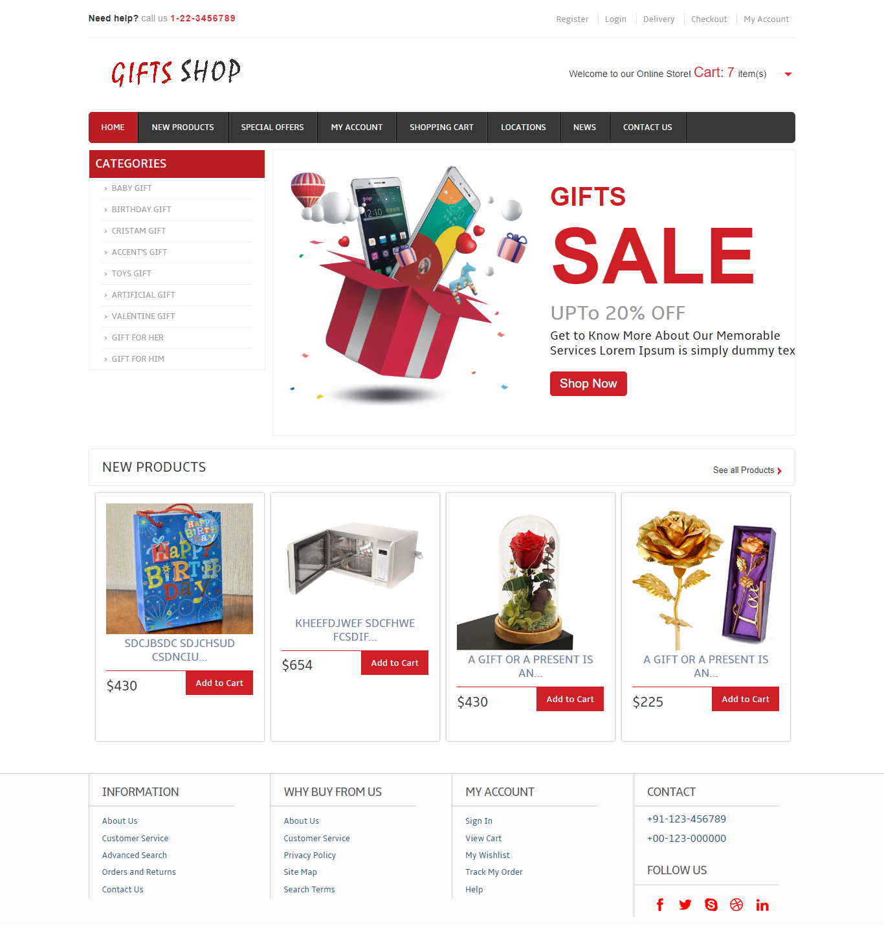

User Registration :

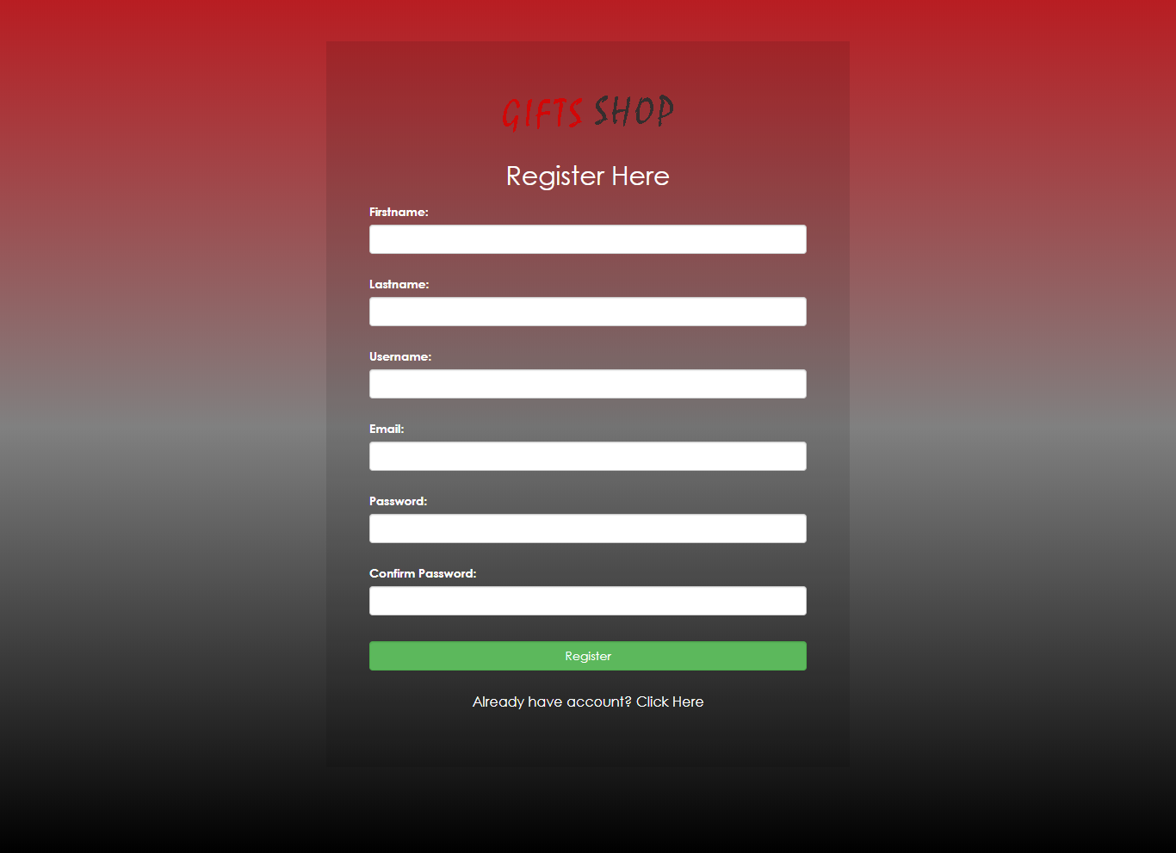

UserHomePage :



Cart :

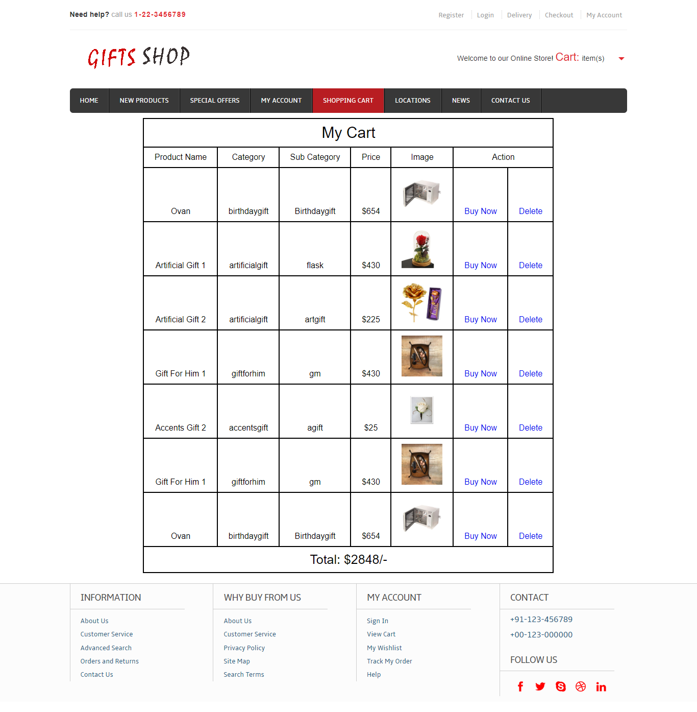

Admin Home :

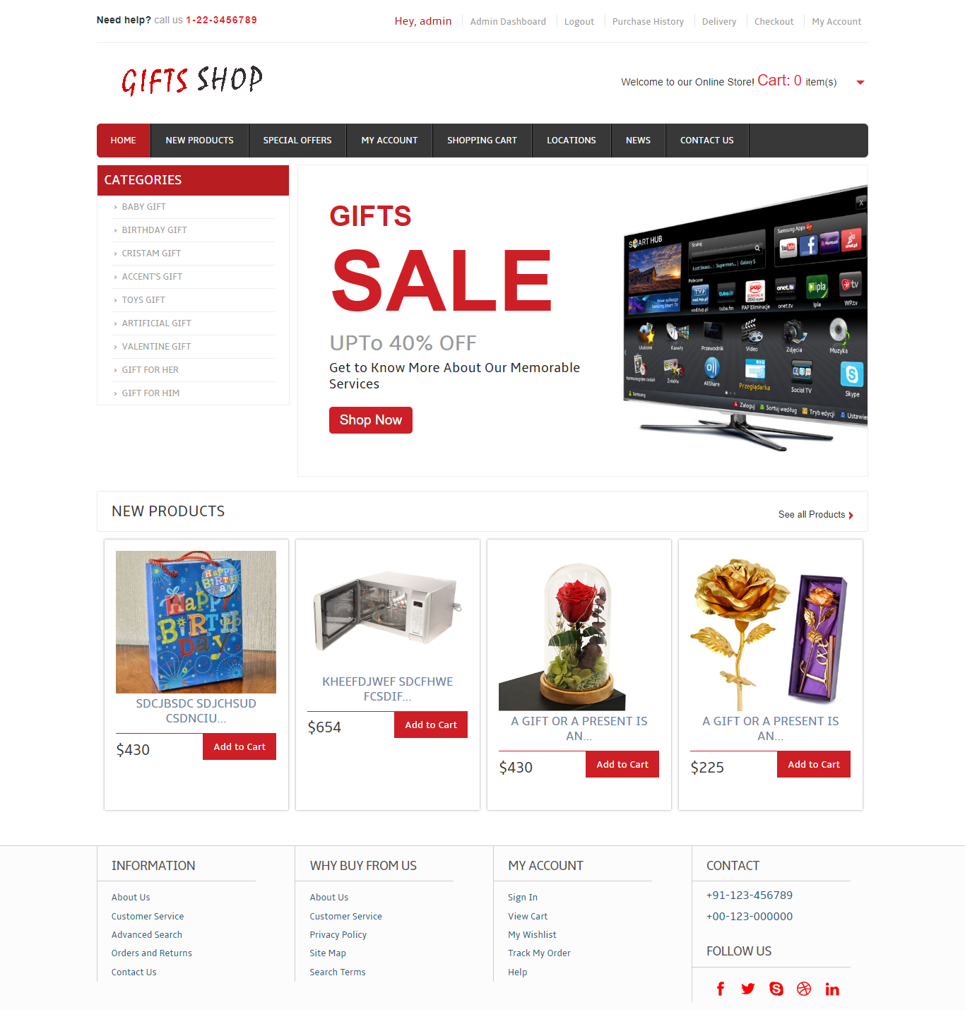

Add Item :

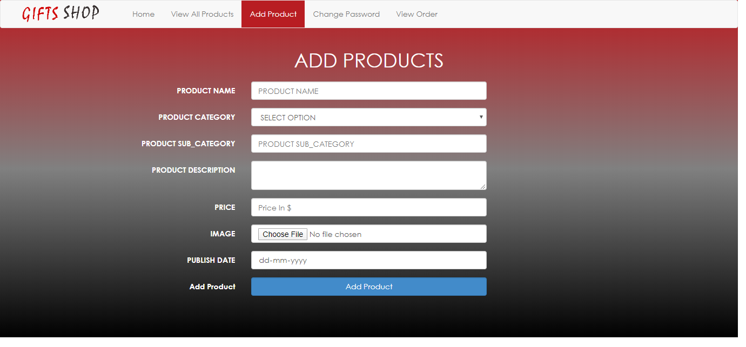

Edit Items :

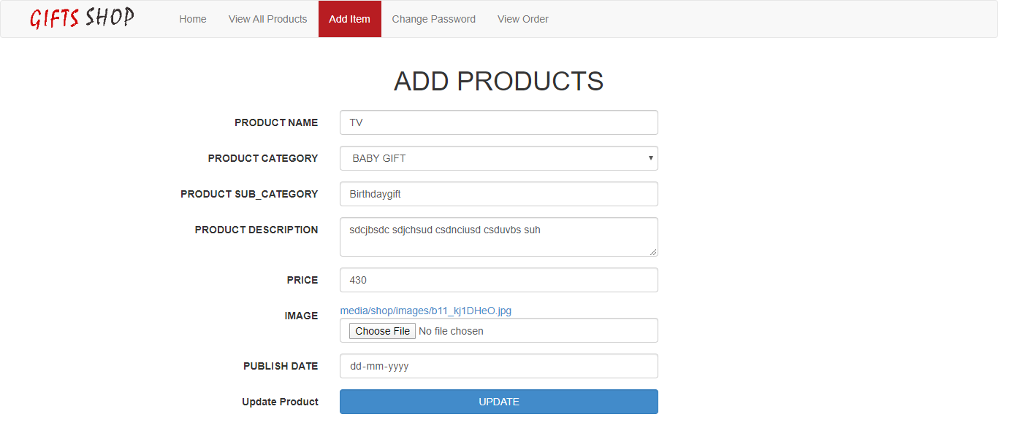

1. **IMPLEMENTATION OF SECURITY**

Security is an important issue for modern IT system. System administrator and security administrator are responsible for safeguard’s organization data and computing infrastructure.

**Password Encryption:** Whatever security measures taken, in any case if anyone with destructive or malicious mind gets access to the database he can temper the critical data. To restrict it we’ve used encrypting algorithm facilitated to us by Microsoft ASP.Net .

Two algorithms’ are there

* SHA1- It takes the password and encrypt it in a string of 40 characters
* MD5- It takes the password and encrypt it in a string of 32characters

The beauty of these Algos are that whatever be the length of password the length of converted string remains same.

However a question arise here that if this thing is that good then why didn’t we used it for storing each and every data????

The answer lies in the fact that not all data are needed to be encrypted as long as we keep the critical data(like password encrypted and safe). It will only increase the load on server and network with no additional advantage. So we’ve not used this encryption Algo on all data blindly.

We have implemented different approach related to security issue for our project “Online Examination” :

**Authorization:**

Super Admin has authorized to give permission to admin for the registration of the students.

**Authentication:**

Only registered students can appear for the examination. Every registered student has different and unique UserId.

**Information Integrity:**

Only Super admin has right in the modification of the information. There is no possibility by the end user or unauthorized user of hacking the information.

**Detection:**

Super Admin will have a bank up of the project. Also there is a complex and alphanumeric password for admin and student. Super admin itself has a complex and alphanumeric password. There is a option for changing the password by all the admin and itself after every month.

**10. FUTURE SCOPE AND ENHANCEMENT OF THE PROJECT**

The system has been implemented and tested successfully. It meets the information requirements specified to the great extent. Although the system has been designed keeping the present and future requirements in mind and made very flexible.

There are limitations of the system. Proper consideration has been given for a wide range of new enhancements. The system is developed user friendly. In future, if it is required to generate reports other than provided by the system it can be simply achieved by a separate module to the main menu without affecting the design of the system. Apart from that a payment gateway module can also be implemented in future.

**11. Conclusion**

The central concept of the application is to allow the customer to shop virtually using the Internet and allow customers to buy the items and articles of their desire from the store.

The information pertaining to the products are stores on an RDBMS at the server side (store).The Server process the customers and the items are shipped to the address submitted by them.

The application was designed into two modules first is for the customers who wish to buy the articles. Second is for the storekeepers who maintains and updates the information pertaining to the articles and those of the customers.

The end user of this product is a departmental store where the application is hosted on the web and the administrator maintains the database. The application which is deployed at the customer database, the details of the items are brought forward from the database for the customer view based on the selection through the menu and the database of all the products are updated at the end of each transaction.

**12. Bibliography**

Designing and implementation phase: -

1. Software engineering: a practitioners approach by roger s pressman.
2. System analysis and design by Elias m. Ewad.
3. DBMS : Bipin C Desai

**Coding phase: -**

1. Python (Complete Reference)

Referenced Sites:

www.tutorialspoint. com

[www.javatpoint.net](http://www.javatpoint.net)